**1. Define an Object**

We define **Payments**, **Products**, **Imports,Customer,suppliers ,Staffs, Invoices**

**2**.**Define Attributes**

Payments(payment_id,amount,currency,payment_date,payment_method,status,payer_id,recipient_id,payer_name,recipient_name,transaction_id,description,reference_number,tax_details,fees)

Products(productID, name,description,category,price,discountPrice,stockQuantity,stockStatus,weight,dimensions,images,brand,rating,reviews,tags,releaseDate,variants,supplier,taxRate,fees,barcode,UPC,status)

Imports(

import_id,source,destination,import_date,status,items,importer,batch_number,import_cost,customs_duties,customs_status,transport_mode,transport_details,documents,priority,quantity,total_weight,total_dimensions,currency,remarks,verification_status,error_count,error_log,completion_date

)

Customers(id, name, dob, address, email)

Staffs(Id,Name,Sex,dob,Address,Current place,email,Workhour,Phone,Salary,)

Suppliers(supplier_id,supplier_name,contact_person,address,email,phone,website)

Invoices(invoice_number,invoice_date,due_date,seller_name,seller_contact,seller_address,seller_tax_id,buyer_name,buyer_contact,buyer_address,buyer_account_number,items,subtotal,tax,discount,total,payment_terms,payment_methods,bank_details,currency,notes,reference_number,legal_info,qr_code,attachments)

**3**. **Define Classes of Objects**

Class Payment{

payment_id,amount,currency,payment_date,payment_method,status,payer_id,recipient_id,payer_name,recipient_name,transaction_id,description,reference_number,tax_details,fees,

set_payment_id(),set_amount(),set_currency(),set_payment_date(),set_payment_method(),set_status(),set_payer_id(),set_recipient_id(),set_payer_name(),set_recipient_name(),set_transaction_id(),set_description(),set_reference_number(),set_tax_details(),set_fees(),

get_payment_id(),get_amount(),get_currency(),get_payment_date(),get_payment_method(),get_status(),get_payer_id(),get_recipient_id(),get_payer_name(),get_recipient_name(),get_transaction_id(),get_description(),get_reference_number(),get_tax_details(),get_fees(),

Payment(),Payment(...)

}

Class Products{

productID, name,description,category,price,discountPrice,stockQuantity,stockStatus,weight,dimensions,images,brand,rating,reviews,tags,releaseDate,variants,supplier,taxRate,fees,barcode,UPC,status,

get_productID(), get_name(),get_description(),get_category(),get_price(),get_discountPrice(),get_stockQuantity(),get_stockStatus(),get_weight(),get_dimensions(),get_images(),get_brand(),get_rating(),get_reviews(),get_tags(),get_releaseDate(),get_variants(),get_supplier(),get_taxRate(),get_fees(),get_barcode(),get_UPC(),get_status(),

set_productID(), set_name(),set_description(),set_category(),set_price(),set_discountPrice(),set_stockQuantity(),set_stockStatus(),set_weight(),set_dimensions(),set_images(),set_brand(),set_rating(),set_reviews(),set_tags(),set_releaseDate(),set_variants(),set_supplier(),set_taxRate(),set_fees(),set_barcode(),set_UPC(),set_status(),

Product(), Products(...)

}

Class Imports{

Import_id,source,destination,import_date,status,items,importer,batch_number,import_cost,customs_duties,customs_status,transport_mode,transport_details,documents,priority,quantity,total_weight,total_dimensions,currency,remarks,verification_status,error_count,error_log,completion_date,

get_import_id(),get_source(),get_destination(),get_import_date(),get_status(),get_items(),get_importer(),get_batch_number(),get_import_cost(),get_customs_duties(),get_customs_status(),get_transport_mode(),get_transport_details(),get_documents(),get_priority(),get_quantity(),get_total_weight(),get_total_dimensions(),get_currency(),get_remarks(),get_verification_status(),get_error_ count(),get_error_log(),get_completion_date(),

set_import_id(),set_source(),set_destination(),set_import_date(),set_status(),set_items(),set_importer(),set_batch_number(),set_import_cost(),set_customs_duties(),set_customs_status(),set_transport_mode(),set_transport_details(),set_documents(),set_priority(),set_quantity(),set_total_weight(),set_total_dimensions(),set_currency(),set_remarks(),set_verification_status(),set_error_count(),set_error_log(),set_completion_date(),

Imports(), Imports(...)}

Class Customers{id, name, dob, address, email,

Customer (…), setID (…), getID (), setName (…),

getName (), setPhone (…), getPhone (), setEmail (…),

getEmail (), setAddress (…), getAddress ()}

Class Staffs{id,name,sex,dob,address,email,workhour,current place,phone,salary,Staffs(),Staffs(----),setId(),getId(),

setName(),getName(),setSex(),getSex(),setDob(),getDob(),setAddress(),getAddress(),setCurrent place(),getCurrent place(),setEmail(),getEmail(),setWorkhour(),getWorkhour(),setPhone(),getPhone(),setSalary(),getSalary(),

Staffs(),Staffs(...)

};

Class Invoices{

Invoice_number,invoice_date,due_date,seller_name,seller_contact,seller_address,seller_tax_id,buyer_name,buyer_contact,buyer_address,buyer_account_number,items,subtotal,tax,discount,total,payment_terms,payment_methods,bank_details,currency,notes,reference_number,legal_info,qr_code,attachments,

set_invoice_number(),set_invoice_date(),set_due_date(),set_seller_name(),set_seller_contact(),set_seller_address(),set_seller_tax_id(),set_buyer_name(),set_buyer_contact(),set_buyer_address(),set_buyer_account_number(),set_items(),set_subtotal(),set_tax(),set_discount(),set_total(),set_payment_terms(),set_payment_methods(),set_bank_details(),set_currency(),set_notes(),set_reference_number(),set_legal_info(),set_qr_code(),set_attachments(),

get_invoice_number(),get_invoice_date(),get_due_date(),get_seller_name(),get_seller_contact(),get_seller_address(),get_seller_tax_id(),get_buyer_name(),get_buyer_contact(),get_buyer_address(),get_buyer_account_number(),get_items(),get_subtotal(),get_tax(),get_discount(),get_total(),get_payment_terms(),get_payment_methods(),get_bank_details(),get_currency(),get_notes(),get_reference_number(),get_legal_info(),get_qr_code(),get_attachments()

Invoices(),Invoices(...)

}

Class Suppliers{

supplier_id,supplier_name,contact_person,address,email,phone,website,

set_supplier_id(),set_supplier_name(),set_contact_person(),set_address(),set_email(),set_phone(),set_website(),

get_supplier_id(),get_supplier_name(),get_contact_person(),get_address(),get_email(),get_phone(),get_website(),

Suppliers(), Suppliers(...)

}

**4.Define Classes Inheritance**

Class Persons{id, name, dob, address, email, Persons(), Persons(……), setID(), getID(),…………..}; ជា class មេ

Class Staffs{salary,workhour,current place,staffs(),staffs(----)setSalary(),getSalary(),setWorkhour(),getWorkhour(),setCurrentPlace(),getCurrentPlace()} ជា Class កូនរបស់ Persons

Class Customers{ Customers(), Customers(…)}; ជា Class កូនរបស់ Persons

Class Process {

id,

dob,

staffID,

SetID(),

GetID(),

Setdop(),;

Getdop(),

Setstaffid(),

Getstaffid()

}; ជា class មេ

Class Import {

supplier_id,

Set_supplierid (),;

Get_supplieid (),

}; ជា Class កូនរបស់ Imports

**5.Define Class Diagram (Relationship)**

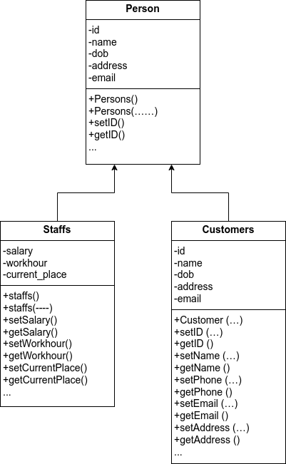

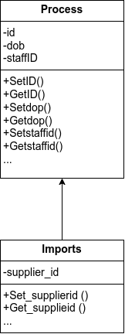

**6. Define object inheritance**

FormPayment relate Classes name Payment, Event, Customer, Staff, Person។